Chairman’s Report

It doesn’t seem almost a year ago that we all last gathered at our AGM, awaiting the arrival of the Club’s then-Chairman Ellis Short at a real time of apathy and uncertainty. Yet a lot has changed since then. We’ve new owners, a few wins under our belt and a whole lot of optimism around the club.

It’s great to hear about ticket applications from Branch members rolling in for every away game now. It’s even better to see so many members in the designated pubs before (and occasionally after) those away games.

A lot of work has been put in by the committee to try and instil vigour into the Branch at a pretty tough time. Thanks in particular to Sam for setting up the online membership application system and to those members who have already joined / re-joined / renewed. Thanks to Andy for taking over the ticketing reins and the great job he’s doing on that.

Thanks also to Tracey for her hard work on tickets over recent years. She’s worked tirelessly for Branch members even after moving back to the North East. Thanks as well of course to Ian who has overseen the fairly seamless transition from paper to online membership applications.

I hope members feel that the Branch continues to prove useful to them. As a Committee we’ve made a conscious effort over the last couple of years to focus on the social aspect (particularly in the absence of any forthcoming deal on travel) and it was heartening to see so many members turn up for the screening of the Sheffield Wednesday game earlier in the season. We will continue to aim to hold at least one social a month.

The Branch will thrive or otherwise due to the contributions not only from our committee (and they are vast) but from every one of our members. If you’re at all willing and able to play any of our sports (football, cricket, darts, pool, quiz), drop a note to the sports captains and get involved. If you go to away games, get the train and go to the pub with us (ask to join the Whatsapp broadcast list for info on that). If you like to meet fellow mackems in London and have a drink, come to our socials.

Thanks to all those members who have done any of the above in the last year and I hope to see you all and double that in the coming year.

Matt Woolston, Branch Chair

Secretary’s Report

During the period since the last AGM, we have had 5 Committee meetings which were attended by an average of 7.2 Committee members. Major items discussed have been the future strategy, structure and future of the Branch, organisation of a number of socials at the Brewery, setting up the new Branch membership module and writing thank you and welcome letters to Ellis Short and Stewart Donald respectively.

Andy McIntosh and Aidan Daly are both up and for re-election at this AGM and have expressed a wish to re-stand for election. Teresa Wilkinson has indicated she does not wish to stand for re-election and is thanked for her efforts over the years. Bernard Hutchinson has indicated a willingness to stand as Membership Secretary on the Committee.

Richie Cockton, Secretary

Membership Report

If ever there was a season to demonstrate the resilience of our membership and their support for, and loyalty to, the Branch, it was the one which finished with relegation on 6th May. Last year I reported a slight drop in our membership to 428 - well we finished this year’s with 416. Within that figure we attracted 25 new members, several of whom were encouraged by their attendance at the social held to celebrate our 50th Anniversary. Once more members were incredibly generous in adding to their subscriptions a total of £750 in donations and we grateful to those who have underlined their support in this way.

There are early and positive signs that this season will reverse the curve, albeit not a steep one, in our declining membership. There is undoubtedly a resurgent interest in the football club and hope that the miseries of recent years can be faded away by the new ownership. I am personally delighted at the reduction in my work of processing memberships which the new on-line system has automated but the change in method has also made it so much easier for a casual visitor to our website to take an instant decision “I’ll have a bit of that”. No more form filling, cheque or bank payment to arrange, or find an envelope and stamp to complete the task. The new fee structure too seems to be aiding enlistment, the group membership category allowing a single payment to cover other family members or friends rather than a totting up exercise of a small separate fee for each additional member.

This move into the electronic age also seemed the perfect time for me to step down from the Membership role. Despite all the paperwork, and the bank visits to deposit cheques, it has been a role I have enjoyed, particularly for the personal contact (albeit mostly in absentia) it provided with our members. I am grateful for the kind messages which I received on announcing my decision but am confident that, provided you elect him this evening, my successor will provide an excellent ongoing service.

Whilst not strictly a membership issue, I have continued to liaise with the football club over the Branch’s involvement with the Sunderland Ladies team. The Branch has, for a number of years, made a sponsorship donation to the club which, as well as demonstrating our support for all activities of the parent club, offered us publicity opportunities to advertise the Branch and increase its profile. Sadly last season, as part of the switch from a summer to winter competition, the move of home games to Mariners Park denied us a permanent advertising board at the home ground. Nor did we enjoy a full page advert in occasional issues of the match day programme SAFShe. As you will be aware the new FA licensing arrangement denied the team a place in either of the top two tiers of national competition and, with so many of its squad leaving, the future progress of the team remains uncertain. In that context, I will not be suggesting the Branch’s sponsorship be renewed.

Ian Todd, Enrolment Officer

Ticket Officer Report
The away game ticket process for the 2018/9 has been subject to changes brought in by the new club ownership, and also me (Andy McIntosh) taking over from the branch side of things from Tracey Hawkins - Hobson. Thanks to Tracey for the many years of hard work she's put in as both tickets and travel officer.
The club sought to implement a system at the beginning of this season whereby each branch application required the SAFC membership number and Black Cats points tally of each individual applicant. This, we think, was to stop fans with the required loyalty points buying tickets themselves from the club and then also obtaining tickets for friends / family through their supporters’ branches.
Whilst we can see the sense in this system, for the London branch this was not going to be useful at all as we have a lot of dedicated fans who travel to many away games but aren't able to maintain a home season ticket due to locational reasons.
As a branch, we liaised with the club and after receiving fairly non-committal responses from them - we've actually managed to strike up a workable process and get all of the tickets that we've requested for Luton, Gillingham, Burton (and have had assurances about Coventry at the time of writing this). We decided not to put in a branch application for AFC Wimbledon due to the small allocation and high demand for tickets.
As ticket officer I've tried to set up my own system to deal with requests and so far it's been going well. To make my life easier and to improve chances of a successful application please can I remind members of the importance of sending an email or text message as soon as possible when you decide to apply, and then a cheque and SAE in the post - this will save me having to go back to the club 2 or 3 times to amend our application. It also helps me to provide timely information to Aidan (treasurer) about applicants and payments to expect.
Andy McIntosh, Ticket Officer
Newsletter Report

Four issues of Wear Down South were published in the 2017-2018, with welcome input from both regular contributors and other members. This was despite it being one of the most depressing seasons in living memory.

It’s always an ongoing challenge for me to find enough copy to fill to each issue, more so now that we are in the lower division and therefore mostly ignored by the media (where I admittedly steal a lot of ideas to fill the pages).

Hopefully the different experiences in League 1 - real old-fashioned football grounds instead of the identikit corporate stadiums in the Premiership, and who knows, maybe winning the odd match now and again – will generate lots of feedback and fresh ideas.

My thanks again to everyone for sending me items – from full articles to letters to the smallest snippet or photo - who has helped keep Wear Down South going strong. Please keep them coming.
Thanks also to our long-time printers, Catford Print.

Eileen Sproates, Newsletter Editor

Website Officer’s Report

The decision was made by the committee last season to facilitate online membership payments. After researching the best method of achieving this we decided to utilise the services of Membermojo (an external site to weardownsouth.com). The system underwent extensive design and testing by the committee (I’d like to pay particular thanks to Ian Todd and Bernie Hutchinson for their efforts in assisting with this). Members are now able to pay via PayPal and can log into their account to maintain their details should they change over the course of the year, reducing the amount of manual administration required by the committee.

The system went Live during July and since then over 330 members have utilised the online payment method and therefore we have seen a significant increase in the number of early registrations compared to previous years. An additional factor may also be been down to the committee decision to provide group memberships for a fixed price (rather than an additional cost per individual – note: only the lead member will receive a copy of WDS).

The website shops remains on hold until the infrastructure required to operate has been decided and merchandise agreed. Other website activity included regular posting of the social sports teams results but this did not lead to significant increase in interest from members. However, the new online registration process includes the ability to sign up for notifications, and as such, members will be contacted in due course by each of the team captains. Facebook was also utilised to attempt to extend our reach/membership and a number of posts were boosted over the course of the year (including the link to the online registration portal).

An overview of the statistics regarding unique website visits can be found below:
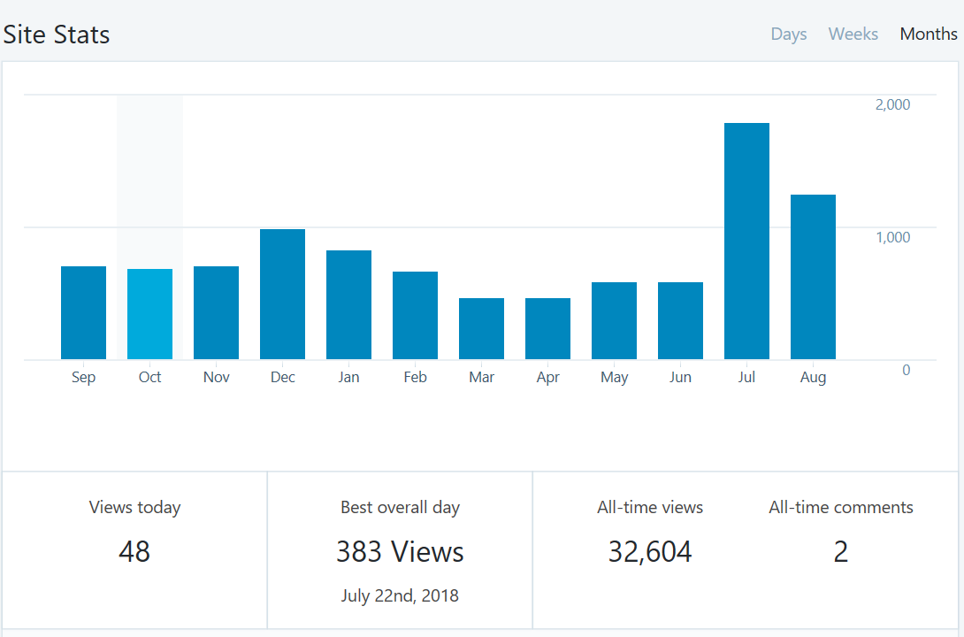
July and August were the months with the most site traffic which coincides with the release of the online registration system.

I’d like to personally thank each of our members who have decided to renew their membership or join via the new online portal and ask for any feedback as to how we could improve the service.
Sam Andrews, Website Officer
Sports Report

Another year passes and whilst there may have been significant changes on the SAFC front, here it's been very much keeping our consistency. Many thanks to the team captains, who manage to get teams out every week. Each sports team is a vital asset to the branch, and is a great way of meeting fellow Sunderland fans far from home. We've seen new players come into the fold and become part of our branch and I would encourage anyone who isn't already a member to do so. Likewise, anyone who has an interest in taking part should drop me an email, which can be found on the website or in the newsletter.

Quiz

The Branch quiz team continues to compete in the Home Counties Football Supporters Club Quiz League, along with teams from Burnley, Charlton, Dagenham, Exeter, Manchester City and Sheffield Wednesday. Quizzes are in standard ‘pub quiz’ format, at the Calthorpe Arms in Grays Inn Road and are normally on the last Thursday of the month from September to April.

Like the club that we represent, the quiz team’s performances could be described as inconsistent. We have won two quizzes in recent years, we have finished bottom more than once, but usually we are somewhere in mid-table. But the beer, the food and the conversation are always more important than the result.

If anyone wants to give it a try, come along next Thursday [27th]

Cricket

"The Cricket Club had a mixed season, as has been the case in recent years. The main success is that the Team kept going. We played a reduced fixture list. Eleven games were planned but only eight went ahead. We won five of these games, including two out of three on our close of season tour at Bury St Edmunds. The fixtures also included an appearance in the Putney Cup where success continues to elude us. However, we can be confident that the Team will be about for another season with pretty much the same fixtures for next year.

Notable individual all-round contributions were made by Matt Woolston (naturally) and John Howey (naturally). Significant batting contributions were made by long-term guests Wilson Digby and St John Costelloe.

The team is self-funding so had no need to look to the Branch for help.

In all, eight Branch members made regular appearances, so we relied again on contributions from guests. While we are grateful for this help, we need to find a way of recruiting more Branch members. We get by for most games but it would mean so much more to have a team made up of Branch members. Any thoughts on how to recruit such players will be gratefully received. The Team's 40th anniversary is approaching so it would be a real achievement to try and restore the Team to something like its former glories",

Football

We struggled for numbers but have had a number of recruits. Just like the Lads, there’s been a downturn in results over recent months but we’re on the up. Performances have improved and a win is just around the corner. New players always welcome. Contact Matt Woolston.

Darts and Pool missing

Andy Jordan, Sports Secretary

